Project Planning Phase
Project Planning Template (Product Backlog, Sprint Planning, Stories, Story points)

Date | 03 February 2026
Team ID | LTVIP2026TMIDS24102
Project Name | Heritage Treasures: An In-Depth Analysis of UNESCO World Heritage Sites
Maximum Marks | 8 Marks

Product Backlog, Sprint Schedule, and Estimation (4 Marks)
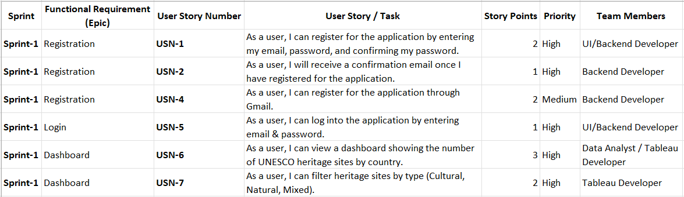

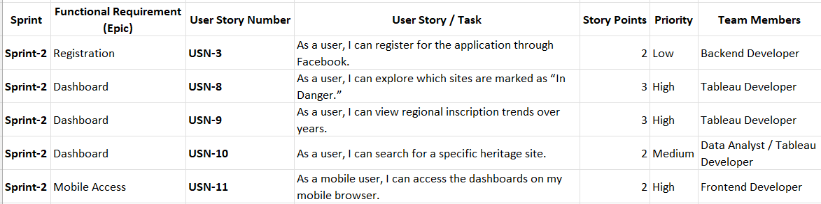

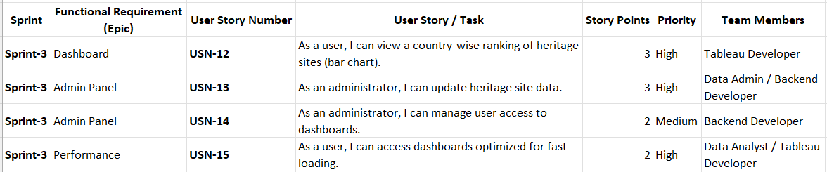

Project Tracker, Velocity & Burndown Chart: (4 Marks)
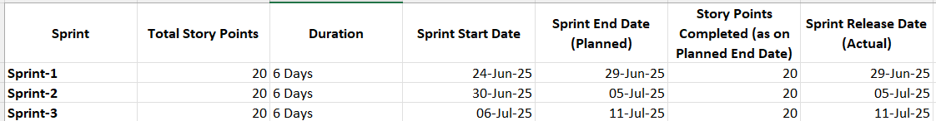

Velocity:
Imagine we have a 10-day sprint duration, and the velocity of the team is 20 (points per sprint). Let’s calculate the team’s average velocity (AV) per iteration unit (story points per day)
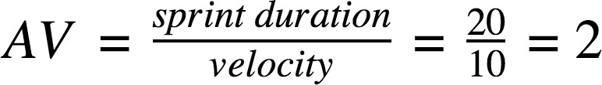

Burndown Chart:

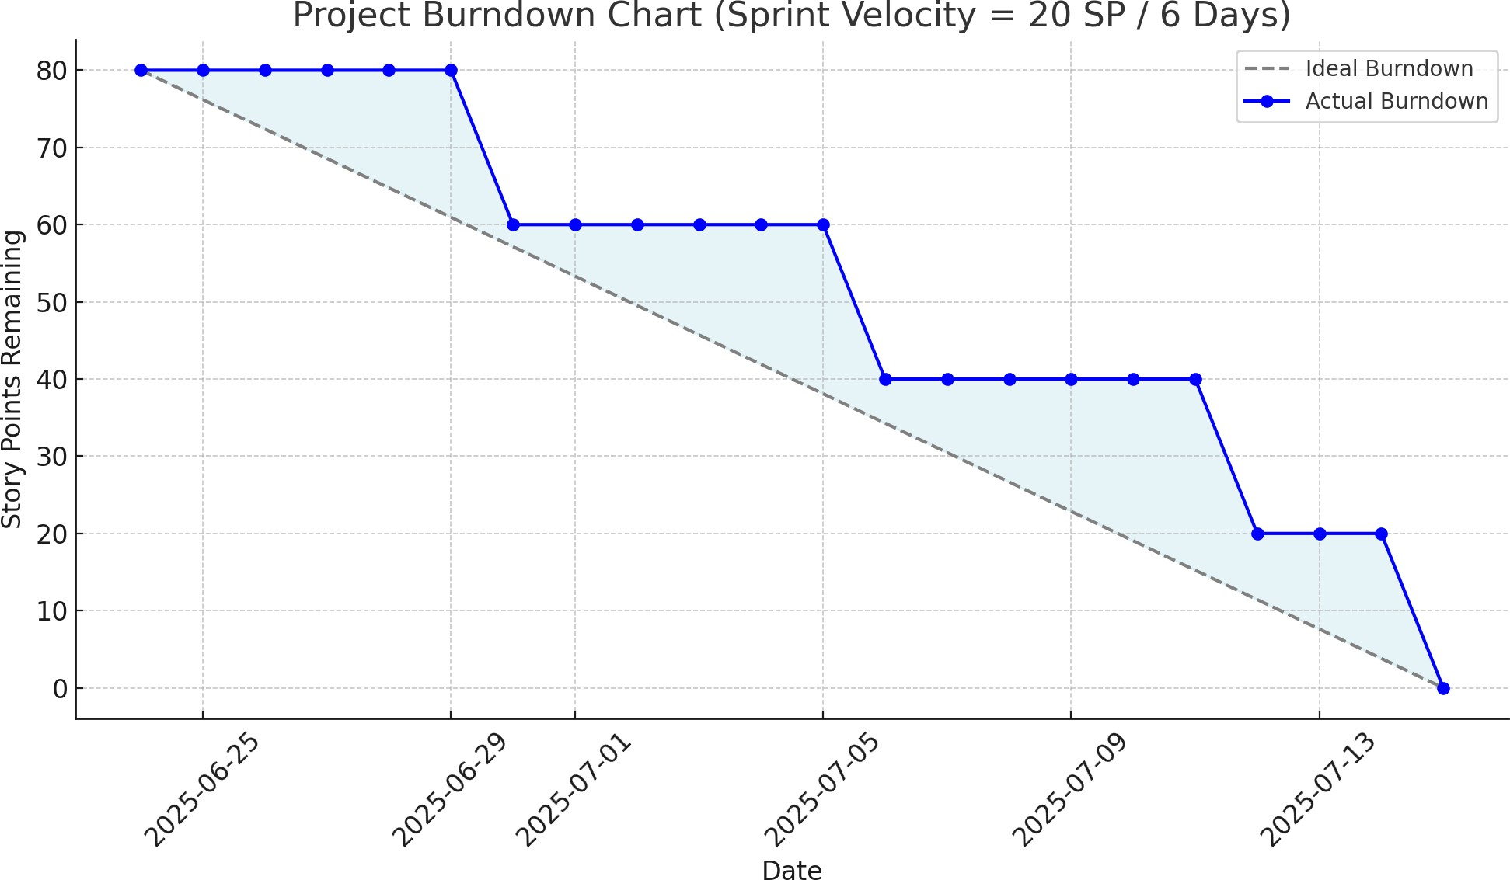

Reference:
https://www.atlassian.com/agile/project-management https://www.atlassian.com/agile/tutorials/how-to-do-scrum-with-jira-software https://www.atlassian.com/agile/tutorials/epics https://www.atlassian.com/agile/tutorials/sprints https://www.atlassian.com/agile/project-management/estimation https://www.atlassian.com/agile/tutorials/burndown-charts

